Q1. How are inline and block elements different from each other?

Block Elements

A block-level element always starts on a new line and takes up the full width available (stretches out to the left and right as far as it can).
Example: <p>, <div>, <form>, <header>, <nav>, <ul>, <li>, <h1>...<h6>

Inline Elements

An inline element does not start on a new line and only takes up as much width as necessary.
Example: <a>, <span>, <b>, <em>, <i>, <cite>, <mark>, <code>

HTML SOURCE:

<!DOCTYPE html>
<html lang="en" dir="ltr">
<head>
<meta charset="utf-8">
<title>Blcok and Inline Elements</title>
</head>
<body>
<h1>This is block Element example<div class="">
BLOCK
</div>element</h1>

<h1>This is example of <span>SPAN</span> element</h1>
</body>
</html>

HTML PAGE

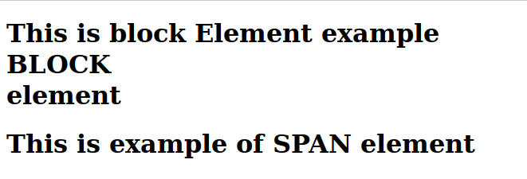

Q2. Explain the difference between visibility:hidden and display:none.

Visibility: hidden

The element will be hidden but it takes width and height of element as specified.

HTML SOURCE

<!DOCTYPE html>
<html lang="en" dir="ltr">
<head>
<meta charset="utf-8">
<title></title>
</head>
<body>
<h2>TEXT ABOVE </h2>
<h2 style="visibility: hidden">HIDDEN TEXT</h2>
<h2>TEXT BELOW</h2>
</body>
</html>

HTML PAGE:
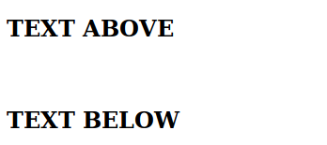

Display: block

The element will be hidden as well as it will not affect the layout. Means it will not take any space(height and width) as specified.

HTML SOURCE

<!DOCTYPE html>
<html lang="en" dir="ltr">
<head>
<meta charset="utf-8">
<title></title>
</head>
<body>
<h2>TEXT ABOVE </h2>
<h2 style="display:none">HIDDEN TEXT</h2>
<h2>TEXT BELOW</h2>
</body>
</html>

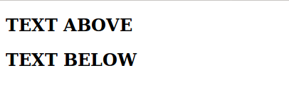

Q3. Explain the clear and float properties.
Float: The float property is used for positioning and formatting content. It is useful when we want to align something on either side of browser along with the other contents. It is very useful in designing menus and writing contents along with images.
Major type of float: left, right, no-float.

HTML SOURCE:

<!DOCTYPE html>
<html lang="en" dir="ltr">
<head>
<meta charset="utf-8">
<title></title>
</head>
<body>
<div class="class1">
<div class="a1" style= "background:green;width:500px; height:500px; float:left">

</div>
<div class="a2" style="background:yellow;width:500px; height:500px; float:right">

</div>
</div>
</body>
</html>
HTML PAGE:


Clear: The clear property specifies on which sides of an element floating elements are not allowed to float.

HTML SOURCE
<!DOCTYPE html>
<html lang="en" dir="ltr">
<head>
<meta charset="utf-8">
<title></title>
</head>
<body>
<div class="class1" style="width:500px; height:500px;">
<div class="a1" style= "background:green;width:200px; height:200px; float:left">

</div>
<div class="a2" style="background:yellow;width:200px; height:200px; float:right">

</div>

<p class="p1">When CLEAR property NOt Used</p>
<p class="p2" style="clear:both">When CLEAR property Used</p>
</div>
</body>
</html>

HTML PAGE:

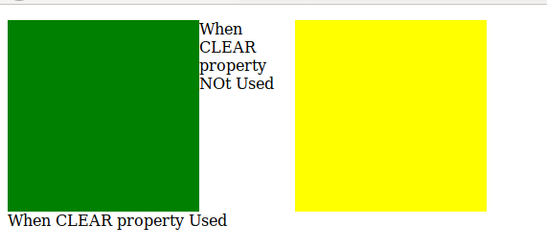

Q4. Explain difference between absolute, relative,fixed and static.
absolute: This is a very powerful type of positioning that allows you to literally place any page element exactly where you want it. We can use the positioning attributes top, left, bottom. and right to set the location. Remember that these values will be relative to the next parent element with relative (or absolute) positioning.

relative: An element with position: relative; is positioned relative to its normal position. Setting the top, right, bottom, and left properties of a relatively-positioned element will cause it to be adjusted away from its normal position.

fixed: A fixed position element is positioned relative to the viewport, or the browser window itself. The viewport doesn't change when the window is scrolled, so a fixed positioned element will stay right where it is when the page is scrolled.

static: This is the default for every single page element. Different elements don't have different default values for positioning, they all start out as static. Static positioned elements are not affected by the top, bottom, left, and right properties.

Q5. Write the HTML code to create a table in which there are 4 columns( ID , Employee Name, Designation, Department) and at least 6 rows. Also do some styling to it.

HTML SOURCE:

<!DOCTYPE html>
<html lang="en" dir="ltr">
<head>
<meta charset="utf-8">
<title></title>
<link href="./Q5style.css" type="text/css" rel="stylesheet">
</head>
<body>
<table id="employee">
<tr>
<th>ID</th>
<th>EMPLOYEE NAME</th>
<th>DESIGNATION</th>
<th>DEPARTMENT</th>
</tr>
<tr>
<td>001</td>
<td>Pankaj</td>
<td>SE</td>
<td>IT</td>
</tr>
<tr>
<td>002</td>
<td>Ram</td>
<td>Manager</td>
<td>Accounts</td>
</tr>
<tr>
<td>003</td>
<td>Shubham</td>
<td>Engineer</td>
<td>CS</td>
</tr>
<tr>
<td>004</td>
<td>Pulkit</td>
<td>SE</td>
<td>CS</td>
</tr>
<tr>
<td>005</td>
<td>Raju</td>
<td>API Dev</td>
<td>IT</td>
</tr>
<tr>
<td>006</td>
<td>Abhay</td>
<td>Support</td>
<td>IT</td>
</tr>
</table>
</body>
</html>

CSS Style Sheet:

#employee{
width: 50%;
border-collapse: collapse;;
}

#employee td, #employee th{
border: 5px solid pink;
color:white;
}

#employee tr:nth-child(even){
background-color: red;
}
#employee tr:nth-child(odd){
background-color: green;
}

#employee th{
text-align: center;
background-color: yellow;
color:blue;
border-style: dotted;
padding: 10px;
}

HTML PAGE:

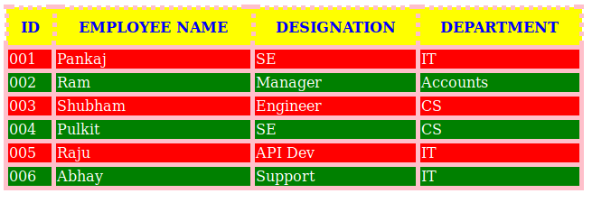
Q6. Why do we use meta tags?

Meta elements are typically used to specify page description, keywords, author of the document, last modified, and other metadata. Also, it helps to improve the SEO( Search Engine Optimization) of a web page by using certain keywords related to the web page.
Following are few examples of <meta> tag with different attributes :
<meta name="keywords" content="HTML, CSS, XML, XHTML, JavaScript"> (For Search engines)
<meta name="description" content="Free Web tutorials on HTML and CSS"> ( Description of web page)
<meta name="author" content="John Doe"> (Author of web page)
<meta name="viewport" content="width=device-width,initial-scale=1.0"> (Responsiveness)

Q7. Explain box model.

All HTML elements can be considered as boxes. In CSS, the term "box model" is used when talking about design and layout. The CSS box model is essentially a box that wraps around every HTML element. It consists of: margins, borders, padding, and the actual content.

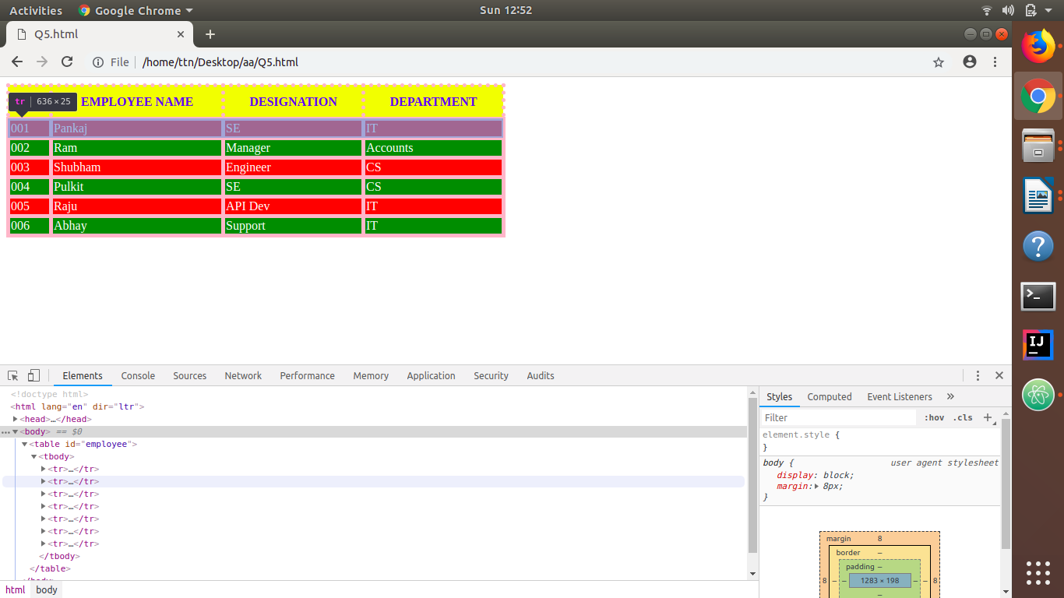

Q8. What are the different types of CSS Selectors?

.class Selector: (dot) . is used to select class names defined as attribute for any element.
Example:
HTML:
<p class=”head”></p>
CSS:
.head {
text-align: center;
}
#id Selector: (#) hash is used to select html elements by ids.
Example:
HTML:
<p id=”empID”></p>
CSS:
#empID {
text-align: center;
}
* Selector: It is used to select all the elements of html file. It means the css rule will be applied for all elements.
Example:
CSS:
* {
Font-size: 15px;
}
Element Selector: It is used to select element by its tag name.
Example:
CSS:
body{
font-size: 15px;
}
p {
font-size: 20px;
}

/* Multiple element selection */
h1, h2, h3 {
font-size: 20p;
}
/* Selection of child element*/
div span {
Color: Tomato;
}

Q9. Define Doctype.

The <!DOCTYPE> declaration an instruction to the web browser about what version of HTML the page is written in.
Example:
<!DOCTYPE html>
Sample HTML File Source:
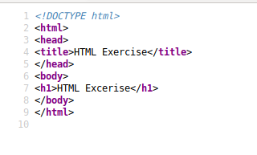

Q10. Explain 5 HTML5 semantic tags.

<header>: It is basically used to define a header for the document or a section
<footer>: It is basically used to defines a footer for the document or a section
<article>: It is basically used to defines an article in the document
<aside>: It is basically used to defines content aside from the page content like sidebar.
<nav>: It is basically used to defines navigation links in the document

11. Create HTML for web-page.jpg (check resources, highest weightage for answers).

Webpage Snapshot:
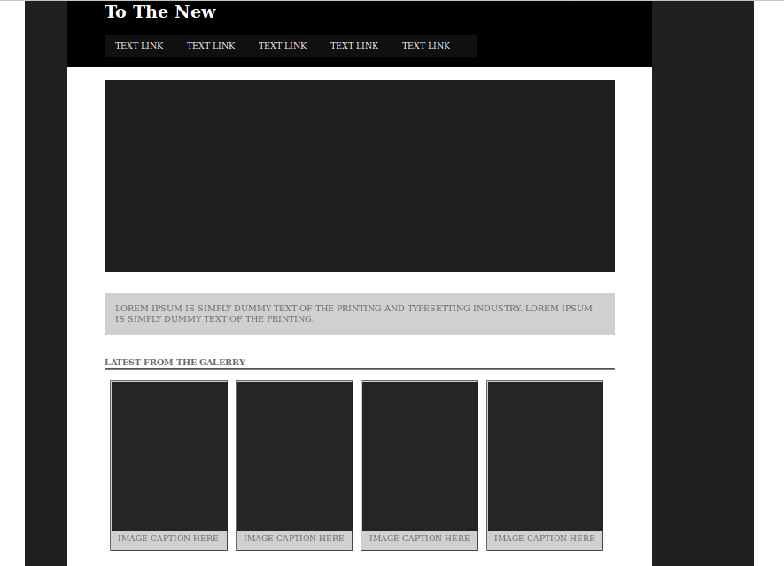
HTML SOURCE
<!Doctype html>
<html>
<head>
<meta charset="utf-8">
<title>Titel Here</title>
<link href="./style.css" type="text/css" rel="stylesheet">
</head>
<body>
<div class="container" > <!--white-->
<div class="inner_container"><!--Grey-->
<div class="inner_container1">
<h1 class="head">To The New</h1>

<div style="background-color: #101010; width: 700px;margin:0px 20px 20px 70px ; " >

<ul>
<li><a href="#home">TEXT LINK</a></li>
<li><a href="#news">TEXT LINK</a></li>
<li><a href="#contact">TEXT LINK</a></li>
<li><a href="#about">TEXT LINK</a></li>
<li><a href="#about">TEXT LINK</a></li>
</ul>

</div>
</div>
<div class="inner_container2">
<div class="inner22">
<div class="inner221"> </div>
<div class="inner222">
<p>LOREM IPSUM IS SIMPLY DUMMY TEXT OF THE PRINTING AND TYPESETTING INDUSTRY. LOREM IPSUM IS SIMPLY DUMMY TEXT OF THE PRINTING. </p>
</div>
<div class="inner223">

<div class="inner2231">
<h4>LATEST FROM THE GALERRY</h4>
<hr style="color:grey;">
</div>

<div class="inner2232">

<div class="in1">
<img src="11.png" width="218px" height="280px" />
<figcaption>IMAGE CAPTION HERE</figcaption>
</div>
<div class="in1">
<img src="11.png" width="218px" height="280px" />
<figcaption>IMAGE CAPTION HERE</figcaption>
</div>
<div class="in1">
<img src="11.png" width="218px" height="280px" />
<figcaption>IMAGE CAPTION HERE</figcaption>
</div>
<div class="in1">
<img src="11.png" width="218px" height="280px" />
<figcaption>IMAGE CAPTION HERE</figcaption>
</div>
</div>

</div>

</div>
<div class="footer">
<footer>
<span>Copyright 2009-2017 -All Right Reserved- To The New</span>
<span>&nbsp;&nbsp;&nbsp;&nbsp;&nbsp;&nbsp;&nbsp;&nbsp;</span>
<span>&nbsp;&nbsp;&nbsp;&nbsp;&nbsp;&nbsp;&nbsp;&nbsp;</span>
<span>&nbsp;&nbsp;&nbsp;&nbsp;&nbsp;&nbsp;&nbsp;&nbsp;</span>
<span>&nbsp;&nbsp;&nbsp;&nbsp;&nbsp;&nbsp;&nbsp;&nbsp;</span>
<span>&nbsp;&nbsp;&nbsp;&nbsp;&nbsp;&nbsp;&nbsp;&nbsp;</span>
<span>&nbsp;&nbsp;&nbsp;&nbsp;&nbsp;&nbsp;&nbsp;&nbsp;</span>
<span>&nbsp;&nbsp;&nbsp;&nbsp;&nbsp;&nbsp;&nbsp;&nbsp;</span>
<span>&nbsp;&nbsp;&nbsp;&nbsp;&nbsp;&nbsp;&nbsp;&nbsp;</span>
<span>&nbsp;&nbsp;&nbsp;&nbsp;&nbsp;&nbsp;&nbsp;&nbsp;</span>
<span>&nbsp;&nbsp;&nbsp;&nbsp;&nbsp;&nbsp;&nbsp;&nbsp;</span>

<span>Web Layout By To The New</span>
</div>
</div>

</div>
</div>
</body>
</html>

style.css

*{
margin:0;
padding:0;
}

.container{
position: relative;
background-color: #737373;
margin:0px 50px auto;
width: 1400px 1000px 1400px 1000px;

}
.inner_container{
position: absolute;
width: 1200px 1000px 1200px 1000px;
background-color: #202020;

}
.inner_container1{
float: left;
width: 1100px;
margin:0px 80px 0px 80px;
background-color: black;
}

.
.inner_container2{
background-color: white;
width: 1100px;
height: 1000px;
}

.inner22{
background-color: white;
margin-left: 80px;
padding-top:100px;
width: 1100px;
height: 1000px;
}

.inner221{
background-color: #202020;
margin: 50px 50px 0px 70px;
width: 960px;
height: 360px;

}

.inner222{
background-color: #D0D0D0;
margin: 40px 70px 40px 70px;
padding: 20px;
color: #686868;
}
.inner223{
color: #686868;
margin: 40px 70px 40px 70px;;

}

.in1{
background-color: #D0D0D0;
margin: 20px 5px 20px 10px;
width: 215px;
height: 315px;
float: left;
border-style: ridge;
font-size: 15px;
text-align:center;
}

.footer{
background:black;
margin-left:80px;
margin-right: 80px;
color: #686868;
padding: 20px 20px 20px 80px;
}

.head{
color:white;
padding-left: 70px;
padding-bottom: 25px;
}
ul {
list-style-type: none;
width: 700px;
padding-top: 10px;
padding-bottom: 10px;
}

li {
display:inline;
background-color: #101010;
}

li a {
padding: 20px;
color: white;
text-decoration: none;

}

12. Create HTML for form.png (check resources, highest weightage for answers).

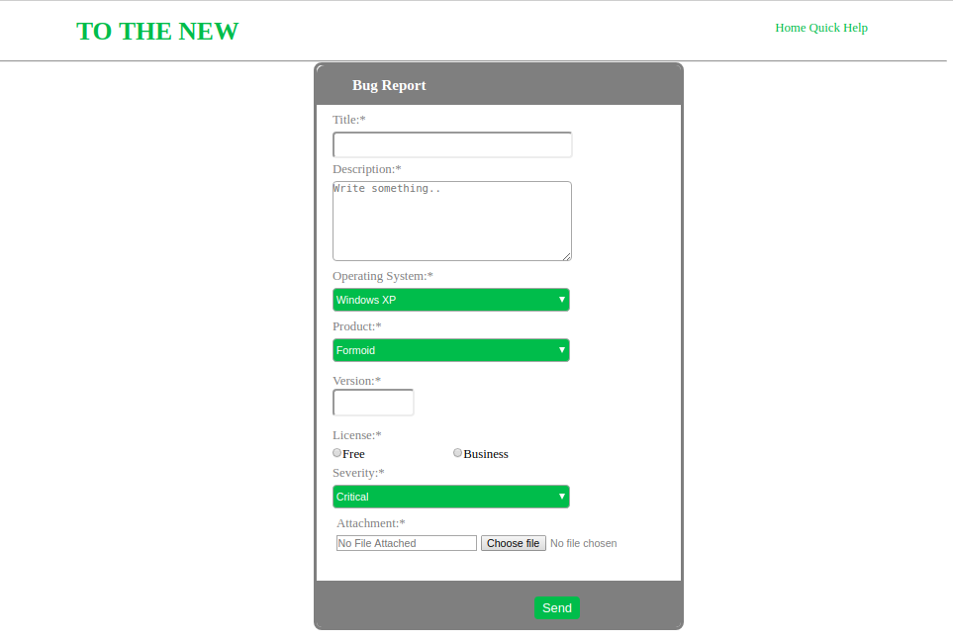

HTML SOURCE
<!Doctype html>
<html>
<head>
<meta charset="utf-8">
<title>Titel Here</title>
<link href="./style2.css" type="text/css" rel="stylesheet">
</head>
<body>
<div>
<div class="header">
<div class="name">
<h1>TO THE NEW</h1>
</div>
<div class="nav">
<span>Home</span>
<span>Quick Help</span>

</div>
</div>
<div><hr/></div>
<div class="bodies">
<div class="bug">
<h3 style="padding-left:45px;padding-top:15px;color:white;">Bug Report</h3>
</div>
<div class="Forms">
<form action="#">

<div class="label1">
<label for="title">Title:*</label>
</div>
<br/>
<div class="label11">
<input type="text" id="title" name="title" style="height:30px; width:300px;border-radius:5px;"><br/>
</div>

<div class="label2">
<label for="description">Description:*</label>
</div>
<div class="label21">
<textarea id="description" name="description" placeholder="Write something.." style="height:100px; width:300px;border-radius:5px;"></textarea>
</div>

<div class="label3">
<label for="os">Operating System:*</label>
</div>

<div class="label31" >
<select id="os" name="os" style="height:30px; width:300px;background:#4CAF50;border-radius:5px;color:white;">
<option value="Windows XP">Windows XP</option>
<option value="Windows 7">Windows 7</option>
<option value="Windows 10">Windows 10</option>
</select><br/>

</div>

<div class="label4">
<label for="product">Product:*</label>
</div>
<div class="label41">
<select id="product" name="os" style="height:30px; width:300px;background:#4CAF50;border-radius:5px;color:white;">">
<option value="Formoid">Formoid</option>
<option value="Formoid2">Formoid2</option>
<option value="Formoid3">Formoid3</option>
</select><br/>

</div>

<div class="label5">
<label for="version">Version:*</label>
</div>
<div class="label51">
<input type="text" id="version" name="version" style="height:30px; width:100px;border-radius:5px;">
</div>

<div class="label6">
<label for="license">License:*</label>
</div>
<div class="label61">
<input type="radio" name="license" value="Free">Free
<span>&nbsp;&nbsp;&nbsp;&nbsp;&nbsp;&nbsp;&nbsp;&nbsp;</span>
<span>&nbsp;&nbsp;&nbsp;&nbsp;&nbsp;&nbsp;&nbsp;&nbsp;</span>
<span>&nbsp;&nbsp;&nbsp;&nbsp;&nbsp;&nbsp;&nbsp;&nbsp;</span>

<input type="radio" name="license" value="Business">Business
</div>

<div class="severity">
<label for="severity">Severity:*</label>
</div>
<div class="severity1">
<select id="severity" name="severity" style="height:30px; width:300px;background:#4CAF50; border-radius:5px;color:white">
<option value="Critical">Critical</option>
<option value="Critical">Critical2</option>
<option value="Critical">Critical3</option>
</select><br/>
</div>

<div class="label7">
<label for="attachment">Attachment:*</label>
</div>
<div class="label71">
<input class="inp" type="attachment" id="attachment" name="attachment" placeholder="No File Attached" style="width:40%">
<input class="file" type="file" name="attachment" value="attachment">

</div>
<br/>
<br/>

<div class="bottom">
<div class="submits" >
<input class="button" type="submit" id="button" name="button" value="Send" >
</div>
</div>

</form>
</div>

</div>
</div>

</body>

</html>

STYLE SHEET
*{
margin:0;
padding:0;
}

body{
width: 1200px;
height: 1200px;
}
.header{
margin-left: 100px;
margin-right: 100px;
width: 1000px;
height: 75px
}
.name{
padding-top: 20px;
color: #4CAF50;
float: left;
}
.nav{
padding-top: 25px;
float:right;
color: #4CAF50;
}
.bodies{
position: relative;
width:460px;
height: 710px;
margin-left:400px;
border-style: solid ;
border-radius: 10px;
border-color: grey;
overflow: hidden;

}
.bug{
background: grey;
width: 500px;
height: 50px;
border-top-left-radius: 10px;
border-top-right-radius: 10px;
}

.label1{
margin-left: 20px;
padding-top: 10px;
float: left;
width: 25%;
color: grey;
}
.label11{
margin-bottom: 5px;
padding-top: 5px;
margin-left: 20px;
float: left;
width: 75%;
color: grey;
}

.label2{
margin-top: 10px;
padding-top: 5px;
margin-left: 20px;
width: 25%;
color: grey;
}
.label21{
margin-bottom: 5px;
padding-top: 5px;
margin-left: 20px;
float: left;
width: 75%;
}
.label3{
margin-top: 5px;
padding-top: 5px;
margin-left: 20px;
width: 30%;
color: grey;
}
.label31{

margin-bottom: 5px;
padding-top: 5px;
margin-left: 20px;
width: 100%;
}

.label4{
margin-top: 5px;
padding-top: 5px;
margin-left: 20px;
width: 25%;
color: grey;
}
.label41{
margin-bottom: 15px;
padding-top: 5px;
margin-left: 20px;
float: left;
width: 75%;
}

.label5{450
margin-bottom: 5px;
margin-top: 5px;
padding-top: 10px;
margin-left: 20px;
width: 25%;
color: grey;
}
.label51{
margin-bottom: 15px;
margin-left: 20px;
float: left;
width: 75%;
}
.label6{

margin-top: 5px;
padding-top: 5px;
margin-left: 20px;
width: 25%;
color: grey;
}
.label61{
margin-bottom: 5px;
padding-top: 5px;
margin-left: 20px;
float: left;
width: 75%;
}

.severity{
margin-top: 5px;
padding-top: 5px;
margin-left: 20px;
width: 25%;
color: grey;
}
.severity1{
padding-top: 5px;
margin-left: 20px;
width: 25%;
color: grey;
}
.label7{
margin-top: 5px;
margin-left: 25px;
padding-top: 5px;
color: grey;
}
.label71{
margin-left: 25px;
padding-top: 5px;
color: grey;
}

.submits{

}

.button {
background-color: #4CAF50;
border: none;
color: white;
padding: 5px 10px;
text-align: center;
text-decoration: none;
border-radius: 5px;
font-size: 16px;
/*margin: 10px 3px;*/
cursor: pointer;
margin-left: 275px;

}

.bottom{
width:480px;
height: 70px;
background: grey;
border-bottom-left-radius: 10px;
border-bottom-right-radius: 10px;
padding-right: 20px;
padding-top:20px;
}

